**Welcome to the Triquetra CNC Family of Triquetra Touch Plate Users**

Frequently Asked Questions

Is the Triquetra compatible with Easel? 2

What about Mach 3/4 Users? 2

When I run the G-Code the bit just pushes my touch plate until it errors out. What causes this? 2

I saved my g-code to a Microsoft Word document and can't load it in to my CAM software. What am I doing wrong? 3

What file extension should I use for my g-code files? 3

I changed my bit mid project. How do I re-zero just my Z-Axis? 3

For Machines running Easel or Carbide Motion 3

For Machines running Mach3 4

For Machines Running Generic GRBL CAM Software 4

Can I set my X and Y axis to be in the center of my material to be carved? 5

When I run the zeroing g-code my bit is not zeroed accurately. What can I do to correct this? 5

I have a variety of different bits. Do I need to create a g-code file for all of them? 5

Where should I position my bit before I run the zero g-code. 6

What is the minimum thickness my material must be to use the Triquetra? 7

I have the new X-Controller from Inventables and when I run the zeroing code it errors out. 8

Where do I connect the wires on my Controller? 8

X-Controllers 8

Mach3 Breakout Boards 9

Demon Shield 9

# Is the Triquetra compatible with Easel?

Answer: Yes, you can zero all three axis in Easel. The Triquetra Tool Box will generate a keyboard macro file that sends commands to Easel via AutoHotKey. AutoHotKey is a free software that you will need to install on your computer that controls Easel. Once installed, you won’t need to load it. You just double mouse click on the keyboard macro file generated by the Triquetra Tool Box to load it into memory. When you are ready to zero your machine you hold down the CTRL key and tap the letter A on your keyboard. Then just follow the instructions that are provided in popup boxes. At the completion of the zeroing process you would continue as normal without resetting your origin. (Use Last Zero Position).

# What about Mach 3/4 Users?

Answer: Support for Mach 3 is now included with the G-Code Generator Version 7 and later. Version 7 is the first release with Mach 3 Support. Due to the vast variety of CNC Machines, there is no way for us to guarantee compatibility. Use at your own risk.

# When I run the G-Code the bit just pushes my touch plate until it errors out. What causes this?

Answer: This can be cause by a couple of things.

1. The number one cause for new installations is a bad ground. The most common mistake is connecting the ground wire to the incorrect spot on the power supply. Please look at the wiring diagram or watch the "Touch Plate Wiring for CNC Routers" video that are available on the Triquetra User Page.
2. Check that the positive wire that goes to you touch plate is firmly plugged in to the Arduino Board at pin A5
3. Check the voltage output. With your power supply turned on and using a multi-meter, place the positive probe on the touch plate and the negative probe on the alligator clip. You should be reading approximately 4.8 volts. If not then re-check your wire connections.
4. Varnished or Burnt bit. Depending on the material you have been cutting with your bit, sometimes it can build up a layer of varnish or become dirty. This will prevent the bit from making an electrical connection with the touch plate. Clean your bit with a solvent or use another bit.
5. Improper household wiring. Your system must be connected to a properly wired power outlet that includes a ground wire. A power outlet that only has two slots and no ground pin will cause errors and is a shock hazard.

# I saved my g-code to a Microsoft Word document and can't load it in to my CAM software. What am I doing wrong?

Answer: Full featured word processors typically do not save files in a purely text format. They normally have lots of formatting codes that are not compatible with any CNC machine. To avoid this, always use a ASCI type editor such as Windows Notepad to save your g-code files.

# What file extension should I use for my g-code files?

Answer: Some post processors and CAM software look for files that have a specific file extension such as .gcode. PicSender and Universal G-code Sender will accept the Windows default file extension used by Note Pad of .txt.

# I changed my bit mid project. How do I re-zero just my Z-Axis?

Answer: If your Post Processor allows for a mid project bit change such as the new version of Easel and then continues to run the same g-code file after the bit change then use the Z axis Zeroing feature in Easel to reset your Z0 to the new bit length. This requires that you have already entered the thickness of your touch plate inside the touch plate settings section of Easel. However, if the bit change happens after the completion of a g-code file then before loading a new g-code file for the next tool path, do the following steps to re-zero your Z axis..

## For Machines running Easel or Carbide Motion

1. Place your Touch Plate on the original corner used for zeroing all three axis -OR- upside down at any location you prefer.
2. Manually Jog your machine so that the bit is over the milled out portion of the touch plate if upside down or over the top right corner region if in the original zeroing position.
3. Connect the banana plug to the touch plate and the magnetic ground to the bit or collet nut.
4. Reload and start the Easel/Carbide Motion zeroing script then choose the option to zero just the Z axis.
5. Done.

## For Machines running Mach3

1. Place your Touch Plate on the original corner used for zeroing all three axis -OR- upside down at any location you prefer.
2. Manually Jog your machine so that the bit is over the milled out portion of the touch plate if upside down or over the top right corner region if in the original zeroing position.
3. Connect the banana plug to the touch plate and the magnetic ground to the bit or collet nut.
4. Click on the Auto Tool Zero button and select the option to zero just the Z axis only
5. Done.

## For Machines Running Generic GRBL CAM Software

1. Place your Touch Plate on the original corner used for zeroing all three axis -OR- upside down at any location you prefer.
2. Manually Jog your machine so that the bit is over the milled out portion of the touch plate if upside down or over the top right corner region if in the original zeroing position.
3. Connect the banana plug to the touch plate and the magnetic ground to the bit or collet nut.
4. Load the Z axis only zeroing file you can create on the same page you used to create zeroing files for various bit diameters in the Triquetra Tool Box. Run that file to reset the Z zero position with the new bit then continue as normal.
5. Done.

# Can I set my X and Y axis to be in the center of my material to be carved?

Answer: Yes. The Triquetra Tool Box has the option to generate files that allow you to enter offset values for both X and Y axis. The offset values are measured along the X and Y axis starting at the front left corner of your material. The touch plate will still be used at the front left corner but after zeroing the zero positions will be offset from that corner.

# When I run the zeroing g-code my bit is not zeroed accurately. What can I do to correct this?

Answer: This is common and due to improper stepper calibration, rough measuring of the touch plate, loose belts and other reasons.. This is This can easily be corrected by the Fine Tuning process in the Triquetra Tool Box. In the tool box go to the "Fine Tuning" page. You can download and print the "Fine Tuning Worksheet" and watch the "Fine Tuning a Detailed Walk Through" video by clicking the video link in the Triquetra Tool Box for instructions. There is also a "Stepper Calibration" video that will guide you through using the "Stepper Calibration" page that can help with consistency. If you change your stepper calibration you will need to fine tune your touch plate to match the new stepper calibration.

# I have a variety of different bits. Do I need to create a g-code file for all of them?

Answer: No. The only g-code files you need to create are files for each bit size in diameter. Bit size refers to the maximum diameter of your bit. This is normally the shank size but not always. For example, you have the following bits: 1/16" ball nose with a 1/8" shank, 1/8" endmill with a 1/8" shank, and 1/8" V-bit with a 1/8" shank. Only 1 file is needed to zero all of these bits because each of them have a 1/8" shank and it is the maximum diameter of each bit and can be positioned so that the 1/8” diameter is the part that makes contact with the touch plate for the X and Y axis during zeroing.

# Where should I position my bit before I run the zero g-code.

Answer: The g-code is written so that the maximum distance it will travel searching for the touch plate is 1 inch. This is to prevent it from continuing to search until it crashes into your limits. Three axis zeroing always starts by probing along the X axis first. So your initial bit position should always be within 1/2" of the right of the touch plate, within 1/2" of the back right corner, and the tip of your bit should be as close to the work surface as possible without actually touching it. Please be aware that during the zeroing process the bit will automatically raise up 1" before it moves over the top of the touch plate to measure the Z axis. You must insure that there is sufficient travel in you Z axis available for this movement. The best way to do this is to position your bit as low as possible before starting the zeroing process. See the images below for corner specific starting locations.

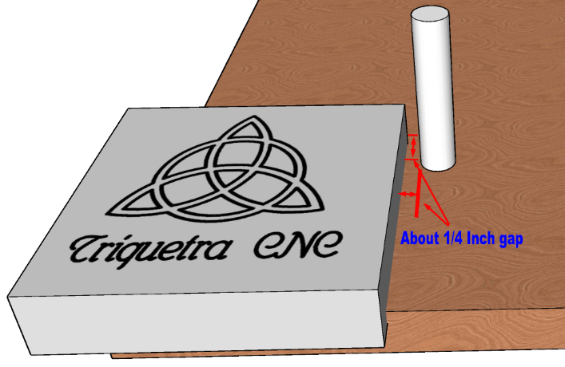Left Front Corner Right Front Corner

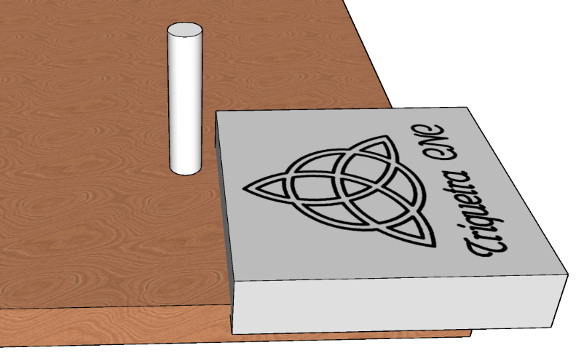

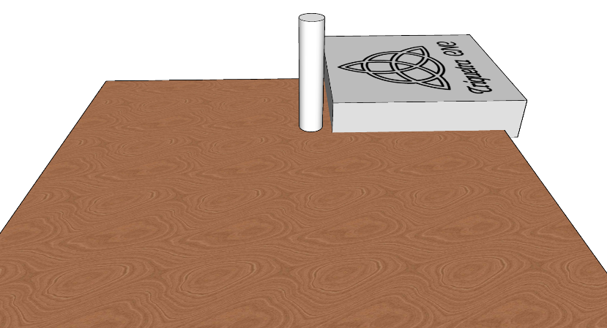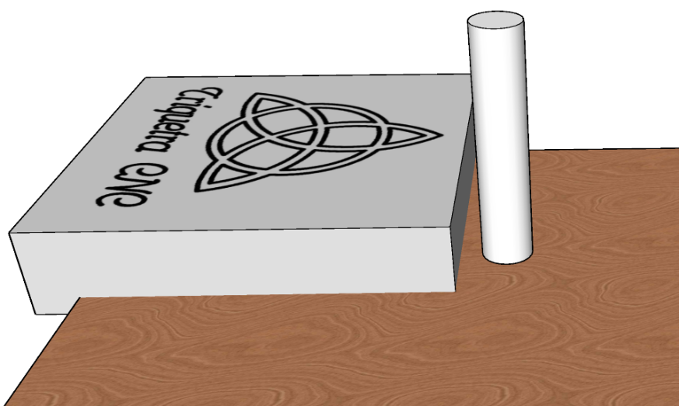Left Back Corner Right Back Corner

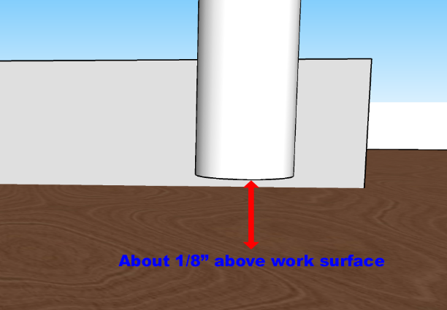

Bit Height at start of zeroing should be as close to material surface as possible without touching. About 1/8 inch works best.

# 

# What is the minimum thickness my material must be to use the Triquetra?

Answer: The stock version of the Triquetra will work with material as thin as 0.22 inches. Special orders can be made for use with thinner material.

# I have the new X-Controller from Inventables and when I run the zeroing code it errors out.

The new X-Controller when used with Universal G-Code Sender will often require the command M02 to be added to the end of the g-code file. Please note that the number zero is used in the command and not the letter O.

# Where do I connect the wires on my Controller?

## X-Controllers

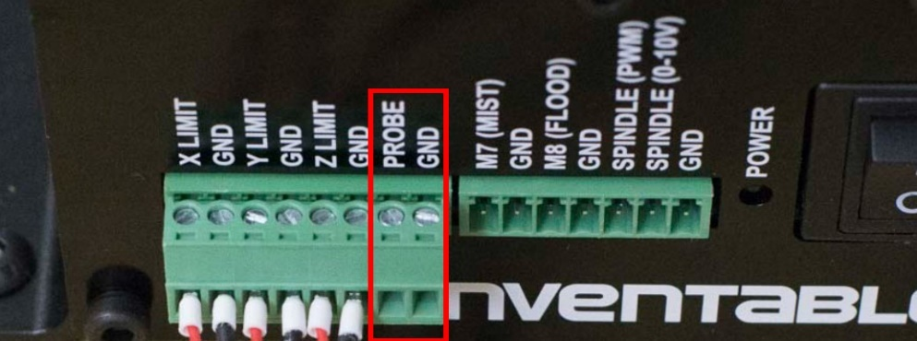If you have an X-Controller you have two options. See images below:

The preferred method is to connect directly to the Controller PROBE and GND ports. Disconnect any existing wires to these ports. If your wire assembly came with a green and black plug, remove it and connect the wire with the Red connector to PROBE and the wire with the black connector to GND.

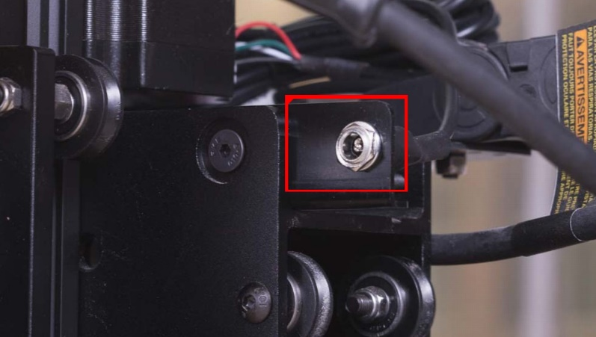

Optional Method: If you machine has the probe port shown in the picture to the left, and your wire assembly has a plug preinstalled then you can simply plug the wire into the port on the gantry for use.

## Mach3 Breakout Boards

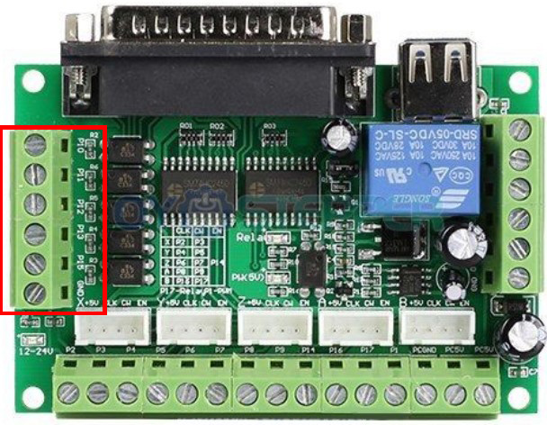

Most all Mach3 breakout boards have 5 inputs. One for Estop, One for Probe, and three for limit switches. Choose any available input pin from pins 10, 11, 12, 13, and 15. Connect the wire with the red connector to one of these input pins and the black wire to an input ground pin.

## Demon Shield

Connect the wire with the red connector the PROBE + terminal and the black Connector to PROBE -